IDEATION PHASE
INTRODUCTION
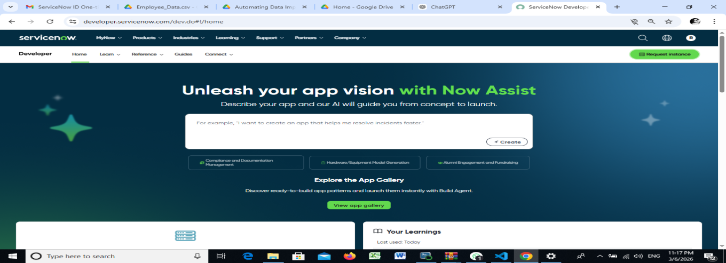

In modern organizations, managing digital platforms and ensuring data accuracy are important tasks. ServiceNow is a cloud-based platform that helps organizations automate workflows, manage IT services, and improve operational efficiency. Many organizations rely on ServiceNow to handle incidents, requests, and internal processes through structured forms and workflows.
One of the common challenges faced by organizations is ensuring that users provide complete and accurate information while submitting forms in the system. If important fields are left empty, it can lead to incomplete records, delays in processing, and confusion for teams handling the requests. Therefore, organizations need mechanisms that ensure important fields are filled before records are submitted.
This project focuses on enforcing mandatory fields using UI Policies and migrating configurations between environments using Update Sets . UI Policies allow administrators to dynamically control form behavior such as making fields mandatory, visible, or read-only. Update Sets help capture configuration changes and move them safely from one ServiceNow instance to another. Together, these features help maintain consistency, accuracy, and efficient platform management.

PROJECT OVERVIEW
The main objective of this project is to demonstrate how mandatory fields can be enforced using UI Policies in ServiceNow and how those configurations can be migrated using Update Sets.
In many organizations, users submit forms such as incident reports or service requests. If important fields such as description, category, or priority are left blank, it becomes difficult for support teams to process the request effectively. UI Policies provide a simple and efficient way to control form behavior and ensure that required fields are completed before submission.
Once these configurations are created, they often need to be moved from a development environment to testing or production environments. Update Sets allow administrators to track configuration changes and migrate them safely between instances without recreating them manually.

PURPOSE
The purpose of this project is to improve data accuracy and platform consistency within ServiceNow. Organizations need to ensure that users provide all necessary information when submitting forms so that requests can be processed efficiently.
By using UI Policies, administrators can enforce mandatory fields and guide users to complete forms properly. This reduces incomplete submissions and improves the overall quality of data stored in the system.
Update Sets are then used to capture these configuration changes and move them between different ServiceNow instances. This ensures that the same configurations are consistently applied across development, testing, and production environments.

PROBLEM STATEMENT
Many organizations experience issues when users submit forms without completing all required information. Missing details such as category, priority, or description can slow down request processing and create confusion for support teams.
In addition, when administrators configure UI Policies or other system settings, those changes must often be replicated across multiple ServiceNow instances. Manually recreating these changes in different environments can be time-consuming and may lead to inconsistencies.
Therefore, organizations need a solution that ensures mandatory fields are enforced and that configuration changes can be migrated efficiently between environments. This project addresses these challenges using UI Policies and Update Sets.
EMPATHY MAP
User Thinks
Users expect the system to guide them clearly while filling forms and prevent mistakes.
User Feels
Users may feel frustrated if forms are confusing or if their requests are rejected due to missing information.
User Says
Users often request systems that clearly indicate required fields and provide a smooth submission process.
User Does
Users fill out forms, submit requests, and expect the system to process their information correctly.

BRAINSTORMING
During the ideation stage, several approaches were considered to solve the problem of incomplete form submissions.
One approach was manual verification, where administrators would check submitted records and contact users to collect missing information. However, this process is inefficient and time-consuming.
Another idea was using client scripts to enforce validation rules on forms. While this approach can work effectively, it requires scripting knowledge and additional maintenance.
A simpler and more maintainable solution is the use of UI Policies, which allow administrators to configure form behavior without complex scripting. UI Policies can make fields mandatory, read-only, or visible depending on specific conditions.
SELECTED IDEAS
The selected idea for this project is enforcing mandatory fields using UI Policies and migrating those configurations using Update Sets .
In this solution, UI Policies are configured to ensure that important fields must be filled before users submit a form. This ensures that the system collects complete and accurate information for processing requests.
Once these configurations are created and tested in the development environment, Update Sets are used to capture the changes and migrate them to other environments. This approach ensures consistency, reduces manual work, and improves system management.

